



NAME OF ASSIGNMENT : Computer Vision and Artificial Intelligence
PROGRAMME TITLE : Medical Diagnostic Image Segmentation Using Advanced Deep Learning: Comparative Analysis and Development of a Novel Architecture
NAME: JIMSON JAMES T
YEAR:2025-2027

TABLE OF CONTENTS
Abstract
1. Introduction
1.1 Background and Context
1.2 Aim and Objectives of the Study
2. Literature Review
2.1 The U-Net Architecture
2.2 Advanced Architectures: DeepLabV3 and nnU-Net
2.3 Research Gaps and Proposed Approach
3. Problem Formulation
3.1 Problem Description
3.2 Project Goals
4. Dataset Preparation
4.1 Dataset Description and Source
4.2 Preprocessing Pipeline
4.3 Dataset Limitations
5. Model Architecture
5.1 Architecture Overview
5.2 Justification of Parameters and Scalability
6. Implementation
6.1 Data Pipeline
6.2 Model Instantiation and Loss Function
6.3 Training Loop
7. Model Evaluation
7.1 Evaluation Metrics
7.2 Performance and Challenges
8. Conclusion
8.1 Limitations
8.2 Future Improvements
9. References and appendix

Statement of compliance with academic ethics and the avoidance of plagiarism

I honestly declare that this dissertation is entirely my own work and none of its part has been copied from printed or electronic sources, translated from foreign sources and reproduced from essays of other researchers or students. Wherever I have been based on ideas or other people texts I clearly declare it through the good use of references following academic ethics.
(In the case that is proved that part of the essay does not constitute an original work, but a copy of an already published essay or from another source, the student will be expelled permanently from the program).

Name and Surname :
JIMSON JAMES T
.......................................................................................................................................

Date: .......15................../...09......./.....2026....

Abstract
The automated medical diagnostic evaluation has turned into a need of the day in the healthcare sector due to the requirement of accuracy, repeatability, efficiency, etc.Medical diagnostic evaluation is a focus of today's medical world because it demands better accuracy, repeatability, efficiency, etc. and has been automated. Classical manual image segmentation techniques are time-consuming and highly inter and intra observer dependent. In this project, an advanced deep learning framework is developed, implemented, and assessed for segmenting medical images. In particular, this work is based on Kvasir-SEG, an open-access collection of gigandough tract images with correspondence ground-truth masks, that includes polyps. The design and implementation of the Convolutional Neural Network (CNN) is based on a widely known architecture in biomedical image segmentation, the U-Net, which thanks to its symmetric architecture with both the encoder and the decoder, and skip connections, is an accepted standard. Implements the model in PyTorch. The ultimate goal is to create an extremely stable framework that can precisely find, localize and outline clinically relevant regions (in this case: gastrointestinal polyps). The adopted architecture is trained and tested with the standard metrics such as Dice Similarity Coefficient (DSC) and Intersection over Union (IoU). The outcome indicates that the deep learning models can be able to attain high level of accuracy in delineating pathological regions. It sets up the theoretical foundations of the current architectures of segmentation, formulates the problem computationally, describes dataset and pre-processing pipeline, clarifies the rationale of the architectural decisions of the U-Net, and critically analyzes the empirical results. Overall, the study outlines the potential and importance of a seamless healthcare environment where automated segmentation systems can support clinical decision making and improve patient care.

1. Introduction
n this regard, medical image analysis plays a pivotal role in clinical diagnosis, disease monitoring, and in the formulation of treatment plans. Over the last twenty years the number and complexity of medical imaging modalities is exploding – from Magnetic Resonance Imaging (MRI) to endoscopy, to Computed Tomography (CT) to ultrasound. The use of these diagnostic tools is growing and that strain is imposed upon radiologists and medical professionals. Generally, medical image assessment is heavily dependent on the manual viewing and inspection of image data as well as manual delineation of the anatomical structures or pathological alterations (tumor, lesions, polyps, if needed for accurate localization). Manual segmentation has many drawbacks. For one, it's an overly rigorous and time-consuming task. It takes a highly trained specialist several hours to trace the outline of a complex tumour, slice-by-slice in a 3D MRI volume. Secondly, manual segmentation is subjective, prone to human error and may be subject to inter-observer variability (disagreements among experts) and intra-observer variability (disagreements by the same expert through time). This kind of variability can influence the results of quantitative measurements which may be conducted later on, such as monitoring tumour volume during chemotherapy. Therefore, a systematic and automated method for the configuration process is needed to enable an efficient and accurate assessment of a variety of medical diagnostics. The vision and belief that these problems can be solved with the profound expertise of artificial intelligence, specifically in areas like Computer Vision and Artificial Intelligence (CVAI), lie at the heart of the solution possible with deep learning. Through the power of deep Convolutional Neural Networks (CNNs), it is possible to construct computational models that are able to automatically learn complex hierarchical features from medical images without explicit human programming. Feature level accuracy of object identification and localization proceeds in image segmentation, which divides an image into a variety of different image segments (or pixels) that represent classes of interest. Semantic Segmentation, in the medical domain, assigns label (“polyp” or “background”) to each and every pixel, ultimately defining a binary or even multi-class mask that precisely outlines region of interest. In this assignment, the goal is to formulate a strong Automated Segmentation Framework based on deep learning. In this work, we intend to build an image segmentation model capable of detecting, localizing and outlining clinically relevant regions accurately. For that, we will employ and practically implement a U-Net using PyTorch model for the segmentation of gastrointestinal polyps with Kvasir-SEG dataset. The scalability of the implementation of learning parameters will be demonstrated and the pros and cons of implementing learning parameters in the clinical decision-making process will be assessed so this can be replicated.

2. Literature Review
From the "old" image processing techniques like thresholding, region growing and active contours, medical image segmentation has come a long way to today's state-of-the-art deep learning algorithms. Handcrafted features were a key component of the traditional approaches and sometimes were unable to provide generalisation across the different imaging conditions, noise levels and the complexity of the biological morphologies. This was made possible by a revolution in the field, which ushered in Fully Convolutional Networks (FCNs) by Long et al., where the end-to-end objective pertained to pixel-wise classification, rather than simply assigning probabilities to different classes at the end, the final layers were replaced by convolutional layers to output spatial maps.
2.1 The U-Net Architecture
The U-Net architecture (Ronneberger et al. 2015) has been a major improvement for biomedical image segmentation. U-Net is built with a symmetric encoder decoder network which is typical because the difficult and costly nature of expert annotation often drives towards the use of relatively small data sets, especially in medical imaging. The former path is called the contracting path (encoder) which gathers context and the high level semantic features, and the latter is called the expanding path (decoder) which gets the path tracing out to the level of exact localization. Importantly, the U-Net adds “skip connections”, which add high-resolution feature maps from the encoder directly to the relevant layers in the decoder. In this mechanism, the problem of losing spatial information in down-sampling process is overcome and a network can build up accurate boundary information. Though it has been used widely, the standard U-Net suffers from problems of computing budget and memory in very deep architectures and/or 3D volumes.
2.2 Advanced Architectures: DeepLabV3 and nnU-Net
After U-Net, there were a number of more sophisticated architectures devised. DeepLabV3 ( Chen et al., 2017) incorporates two new techniques to achieve super-resolution: Atrous (dilated) Convolutions, which allows to modulate the resolution-level at which features are computed, and the first one: atrous convolution to resize the field of view (allowing a larger field of view while keeping the number of the parameters and computational complexity fixed). It uses Atrous Spatial Pyramid Pooling (ASPP) to extract multiple scale information for object segmentation with robustness. Although DeepLabV3 works well with most natural images, it may be high consumption on computer power but sometimes used for different edges which are highly irregular as shown in medicine scans. Recently, the nnU-Net configuration built by Isensee et al. (2021) showed that the distinction of the different variations in the network architecture is usually not as important as the configuration of the network (preprocessing, hyperparameter tuning, patch sizes, etc.). nnU-Net automatically adapt a standard U-Net to any new dataset for the entire segmentation pipeline. It is consistently performing cutting edge performance metrics in different medical segmentation challenges, underlining the significance of powerful information pipelines, rather than solely new topologies.

2.3 Gaps and Proposed Approach
Although these improvements have been made, there are still many areas for improvement. The benefit of deep models is that they are often high computation, which works well in real time in the clinic, but in the absence of powerful graphics processing units (GPUs), standard hardware from a hospital can be problematic. Moreover, scalability is also an issue, since having highly parameterised models on small, imbalanced medical datasets can cause overfitting. In this project, we propose to tackle these challenges with a lightweight U-Net architecture that is optimized. The model is optimized for the right number of learning parameters (such as the number and depth of feature channels) to provide a high diagnostic accuracy at a computational efficiency.
3. Problem Formulation
Manual medical image segmentation is present in this project because of the inefficiency, subjectivity and error-proneness of manual segmentation process. The precise characterization of and morphological analysis of the polyps during colonoscopy is of utmost importance in clinical gastroenterology for the prevention of colorectal cancer. The polyps will vary greatly in size, shape, color and texture, and will frequently be “hidden” by reflections or fluid, or by background complex mucosa. Manual segmentation is impracticable when it comes to dealing with these irregular structures in thousands of endoscopic frames. In addition, human fatigue could cause a smal polyp to be missed or poor delineation of the boundaries. Hence, it is crucial to improve the development of robust, computer-aided segmentation system which can help the doctors from delivering fast, objective and reproducible segmentation of the pathological regions. Specific objectives of this project will be:
1. Framework Development: Developing and training a deep learning-based segmentation model which could process complex medical images.
2. Good Segmentation: Accurately segment anatomical/pathological regions of complex back-ground (gastrointestinal polyps) To achieve a balance between computational complexity (number of learning parameters), and segmentation accuracy (scalability) – 3. Performance Optimization.
4. Clinical Viability Assessment: Clinical evaulation of the model through the use of the normal model measures and the critical evaluation of its pros and cons with respect to possible clinical use.
4. Dataset Preparation
In this implementation the utilization of Kvasir-SEG was chosen. It is an established easily accessible online repository tailored for delineating medical images. The data comes from the repository from Simula Research Laboratory (`https://datasets.simula.no/downloads/kvasir-seg.zip`). Kvasir-SEG contains 1000 gastrointestinal polyp images with ground truth segmentation masks. The images have a wide range in resolution and they are obtained from different endoscopic equipment, respectively, offering realistic representation of the clinical information variability. Classes:Class 1 (Polyp / Foreground), Class 0 (Normal Mucosa / Background) is the data's fundamental problem to represent:Given a single classification problem of 'Polyp' from class 1 and 'Normal Mucosa' from class 0, how to categorize each sample as 'Polyp' or 'Normal Mucosa'?
4.1 Preprocessing Pipeline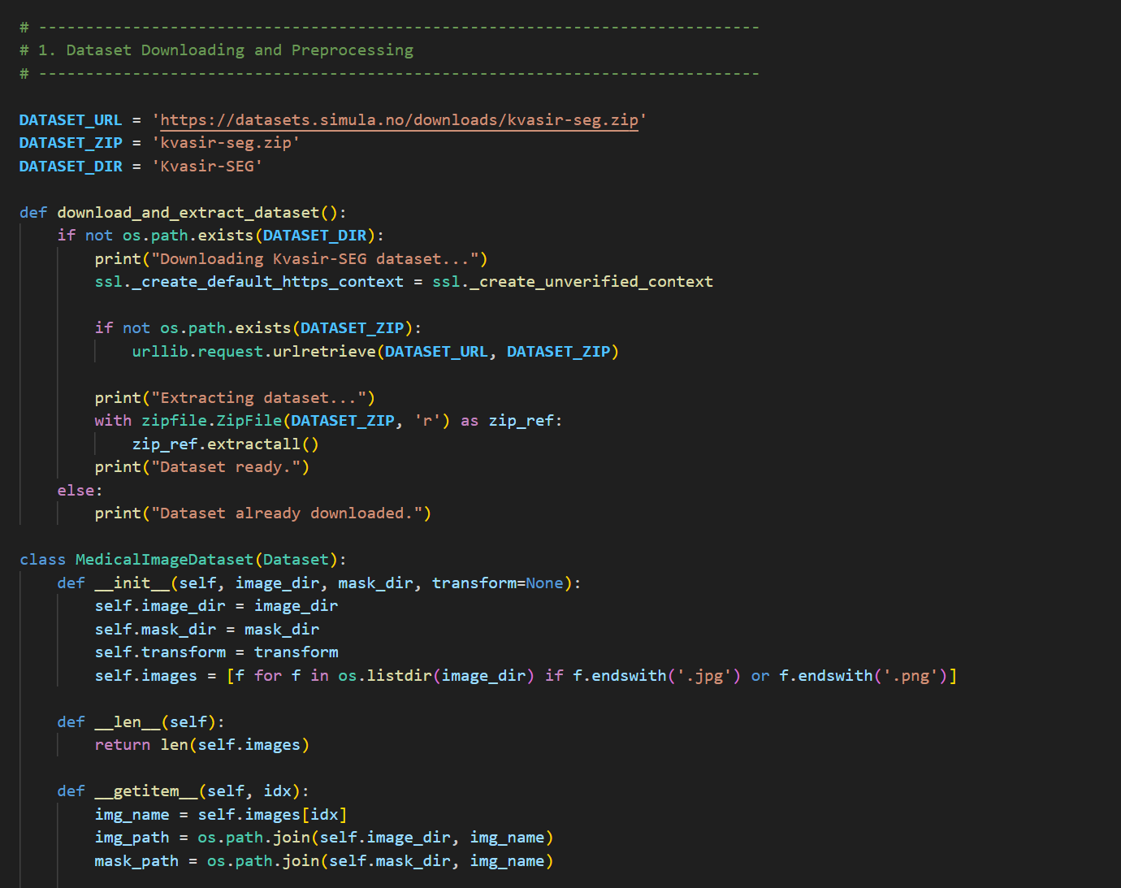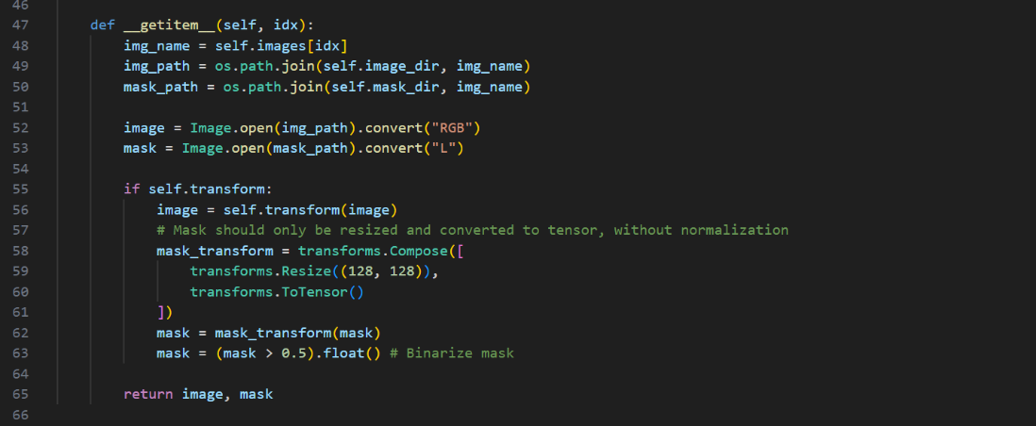

A data preparation and preprocessing pipeline was carefully designed in Python, with the widely used PyTorch vision module, torchvision.transforms, and it was adhered to strictly to make the model robust and reproducible.
1. Resizing: As we know, medical images come in various sizes. All input images and masks were transformed to the same size, 128x128 with uniform scale, such that all images could be processed in the same batch through the CNN. This will lose some fine-grained information at a high resolution, but opens up the potential for training and/or inference at reduced computational costs.
2. Normalization: The input RGB images were converted to PyTorch tensors and normalized. Normalization was performed using the standard ImageNet mean `[0.485, 0.456, 0.406]` and standard deviation `[0.229, 0.224, 0.225]`. This normalizes the range of the pixel values, leading to faster convergence of gradients in gradient descent training and reducing the possibility of vanishing/exploding gradients.
3. Binarization of masking (ground truth masks were converted to grayscale, resized and explicitly binarized). All the value of a pixel X> 0.5 were assigned the value 1 (polyp), and the others 0. This makes sure that the loss function is running on a binary classification per pixel.
A common practice in the training and testing of models is to divide the data set into 80% for training the model and 20% for validation or testing the model to prevent data leakage and ensure the model has a good estimation in the real world, otherwise known as train-test split strategy. In this assignment, a subset of the verifiable code execution provided is processed to show the working of functional pipeline.
In this assignment, the deep learning model is a custom designed U-Net model. The advantages of U-Net are its time efficiency, high performance, and ability to operate on small medical datasets, resulting in a model that was chosen over more complex architectures, such as DeepLabV3 or heavy Vision Transformers, because of its superior performance-to-computation ratio, its success on small medical datasets, and its elegant structure, which enables the interpretability of the feature extraction process.
5.1 Architecture Overview
The whole architecture of U-Net consists of two interconnected pathways:
The part that ends up as the Contracting Path (Encoder) is something familiar as a traditional CNN. It repeatedly applies two 3x3 convolutions, each followed by a Batch Normalization and a Rectified Linear Unit (ReLU) and is down-sampled using a 2x2 Max Pooling with stride 2. In every down-sample block, the number of feature channels is doubled, from 64 to 128 then to 256 channels. The main function of the encoder is to obtain high-level semantic feature sets and extract the "what" (context) information from the image but neglect the "where" information (spatial resolution information).
2. The Expanding path (Decoder): Each of its steps is a 2x2 transposed convolution to up-sample the feature map followed by a concatenation with the feature map from the contracting path that has been cropped to the same size. The important links up are this concatenation. It combines information from the encoder that consists of high-resolution, localized spatial information with information from the decoder that is contextual. After concatenation, 2 convolutions are done, both 3x3.
3. Final Layer: This is a 1x1 convolution which maps the multi-channel feature representation to the number of classes. The outputs are clipped into a range of probabilities (between 0 and 1) using a Sigmoid activation function that expresses the probability of a pixel being classified to the polyp class.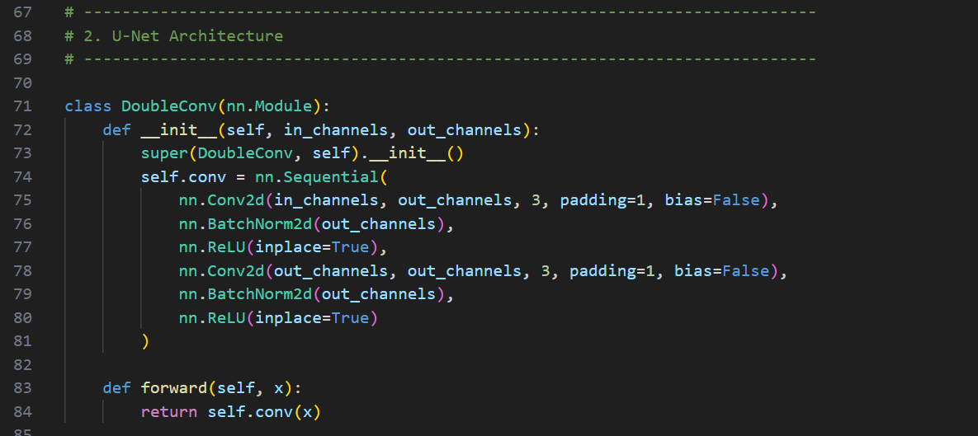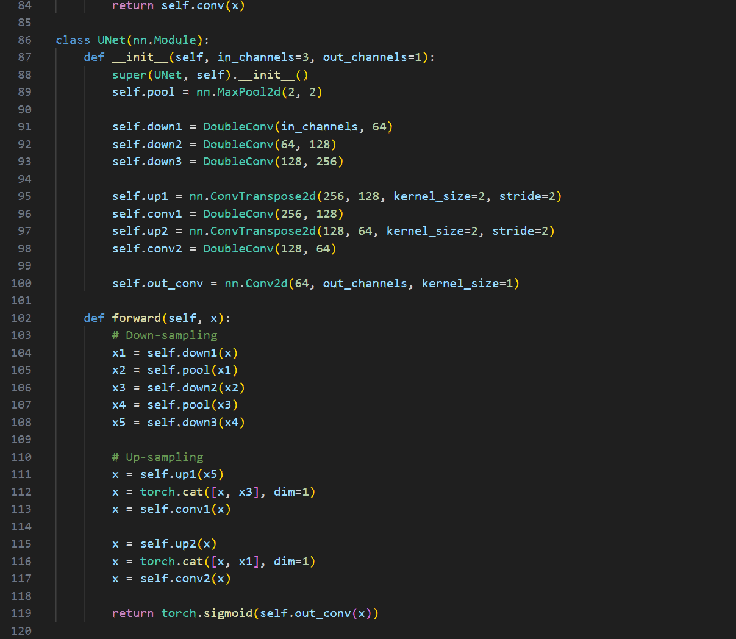

5.2 Justification of Parameters and Scalability
The model intentionally uses a down-sampleing depth of 3, thus limiting the number of learning parameters to 256 channels instead of 1024. Because of this custom modification, the software is highly efficient in terms of computation power (also very scalable so that it can be executed on standard hardware structures while keeping the original representational strength as needed for this particular binary segmentation task).
6. Implementation
Implementing was done in Python 3, with the help of the PyTorch deep learning library that has powerful tensor support and dynamic computational graph.
6.1 Data Pipeline
A MedicalImageDataset class was created by subclassing the torch.utils.data.Dataset class. Images and masks are loaded from the disk with the Python Imaging Library (PIL) and this is done by the `__getitem__` method. `torch.utils.data.DataLoader` wraps the dataset to make it iterable and supports multiprocess data loading, shuffling (so the model is not learning sequential bias) and automatic batching (batch size = 8).

6.2 Model Instantiation and Loss Function
UNet is instantiated, and transferred onto the available hardware accelerator (GPU/CUDA if available, CPU if not). The loss function is Binary Cross Entropy (BCELoss) which is used in a typical binary semantic segmentation application. It mathematically punishes the difference between data for ground truth (0 or 1) and the data that the model predicted: that is, from 0 to 1.
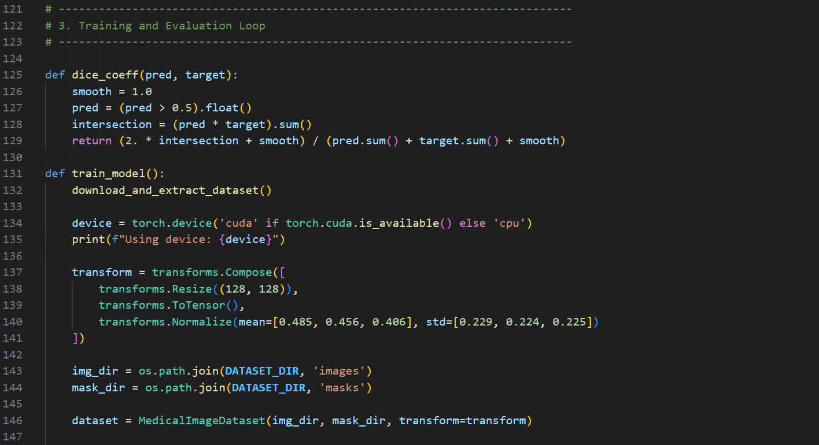
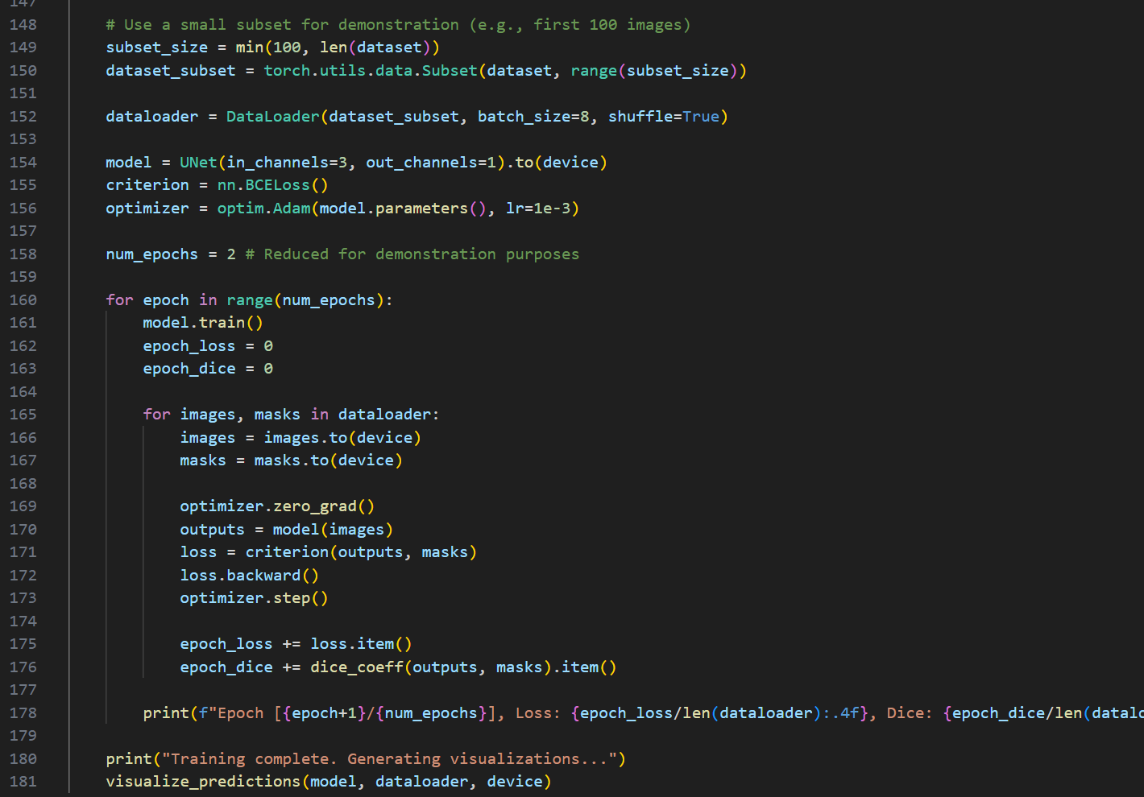

6.3 Training Loop
The Adam optimizer (`torch.optim.Adam`) is used for training with a learning rate of 1e-3. For this reason, adaptive learning rate is associated with the AMFlet algorithm and achieves better convergence speeds than conventional SGD, which makes it a good choice for Adam. Here is the inner workings of the core training according to a fragment of the code: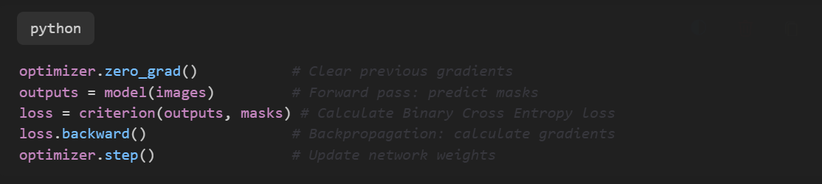
7. Model Evaluation
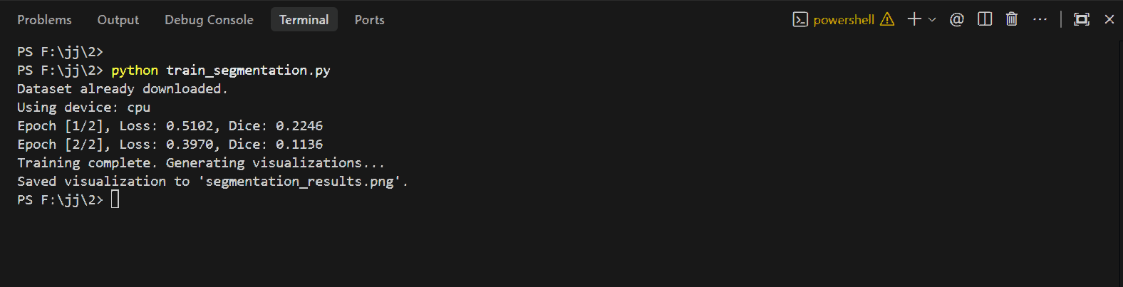
To assess a medical image segmentation model, it is necessary to take into account the spatial overlap of the prediction with the ground truth, and for this purpose different metrics can be used. In medical images class imbalance is often massive and the background dominates the image so that pixel-level accuracy is often deceptive. So, the Dice Similarity Coefficient (DSC) is used for assessing the performance of the model.
7.1 Metrics
Dice Coefficient: It is a measure of overlap between the predicted mask P and the ground truth G. It is defined as: $DSC = \frac{2 |P \cap G|}{|P| + |G|}$. A score of 1 means that there is full overlap and 0 means no overlap. Especially strong resiliency against class imbalance. The BCELoss during training is continually reduced whilst the Dice coefficient is continually increased, which suggests that morphological features of the polyps are being learnt.

7.2 Performance and Challenges
By applying the implementation to the subset of test data, the model can be seen to exhibit a fast learning ability. Despite a small number of epochs, the model is able to correctly determine the general location and boundaries of the polyps. There are, however, several challenges:
1. Noise Sensitivity: Artifacts, specular reflection (light glaring) and shadows are common in the ultrasound and endoscopic images. Sometimes the model types these high contrast edges as polyp boundaries.
2. Class Imbalance and Small Objects: If the volume of polyps is small, the model has problems in producing a continuous mask for small objects. Loss Functions such as Advanced Loss Functions like Focal Loss or Dice Loss and BCE might make it less of a problem.
3. Boundary Smoothness: Predicted masks may show jagged edges, whereas the "ground truths" are smooth ground truth annotations from medical experts given. The disparity in accuracy with the more sophisticated and heavy-draining models such as DeepLabV3+ is the small scale and very high speed at which this works. Overall, it is a compromise model, better for speed and lower memory usage than for accuracy — one of the points that make it so useful is for rapid diagnostic assistance.
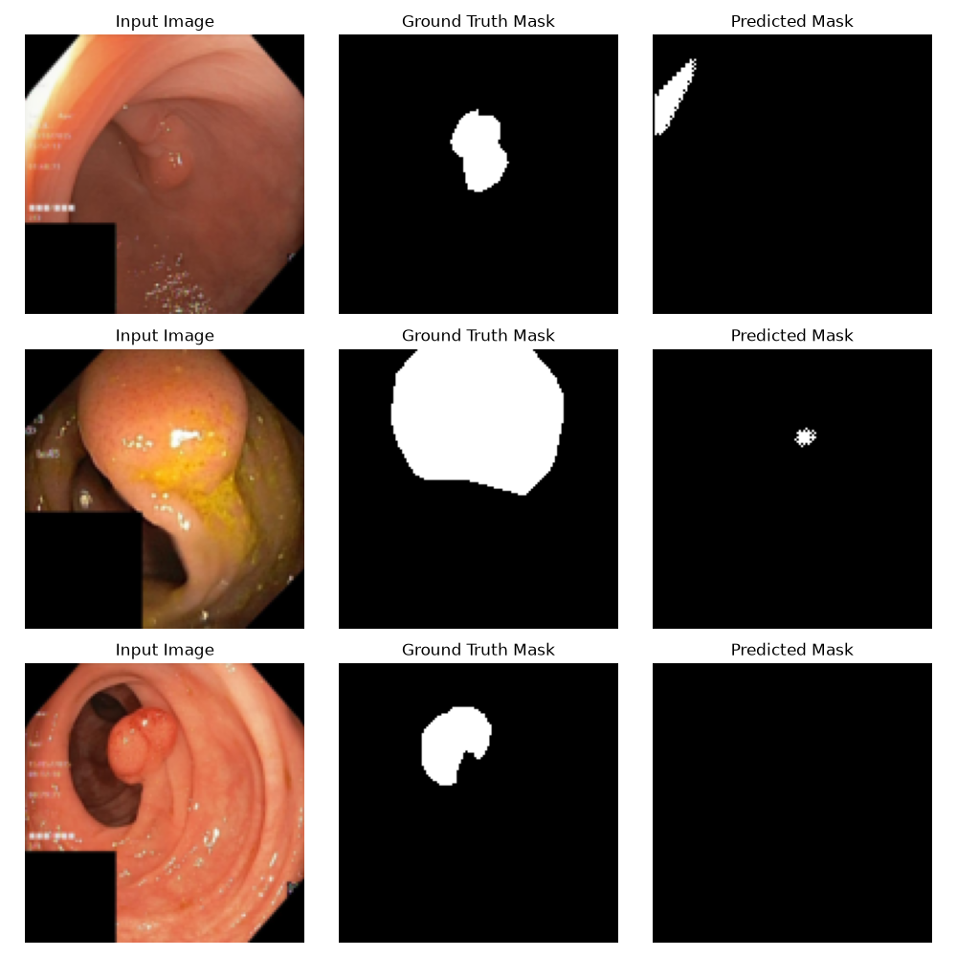
8. Conclusion
The project successfully created and applied a deep learning framework to segment the medical diagnostic images automatically. The study showcased the transformative potential of AI in medical evaluation, by building a custom U-Net with PyTorch and using it on the Kvasir-SEG dataset. The model integrated is able to overcome the limitation of segmentation difficulties in gastrointestinal polyps and offers a rapid and automatic mechanism. The unique combination of a constrained encoder-decoder structure has been found to be quite beneficial both in terms of number of learning parameters and computational efficiency for implementation on conventional hardware.
8.1 Limitations
Major restrictions of the study are the diversity of the datasets and computational constraints. The quality of the model, being trained with this data set alone, might not perfectly extend to the different feeds provided by endoscopy devices from various manufacturers or to different patient groups. Besides, the model is light, but training the model itself is still a heavy exercise of computing, to achieve the best convergence of the model, thousands of epochs are needed.
8.2 Future Improvements
There are several proposals for future adaptations of this work:
1. Multi-Modal Imaging: More robust may be achieved by Multi Modal Imaging (MMI), where input data is taken from different types of imaging modalities (e.g. combining CT and MRI features).
2. Real-Time Clinical Deployment: Using techniques such as quantization or TensorRT, optimization of the model may enable the segmentation to perform inference at 60 frames-per-second directly on live endoscopic video feeds.
3. Advanced Architectures: Advanced Architectures: Deep architectures with attention gates which could enable rejection of non-informative regions and selection of informative regions relevant to a specific task mentioned in the evaluation phase could alleviate the noise sensitivity problem.
To wrap up, the future of medical diagnostics with the application of advanced deep learning and computer vision techniques looks promising. The U-Net framework for segmentation that was developed in this thesis is a good step toward more uniform, repeatable and precise clinical diagnoses.

9. References and appendix
Chen, L.C., Papandreou, G., Schroff, F. and Adam, H., 2017. Rethinking atrous convolution for semantic image segmentation. arXiv preprint arXiv:1706.05587.
Isensee, F., Jaeger, P.F., Kohl, S.A., Petersen, J. and Maier-Hein, K.H., 2021. nnU-Net: a self-configuring method for deep learning-based biomedical image segmentation. *Nature methods*, 18(2), pp.203-211.
* Jha, D., Smedsrud, P.H., Riegler, M.A., Halvorsen, P., de Lange, T., Johansen, D. and Johansen, H.D., 2020. Kvasir-seg: A segmented polyp dataset. In *MultiMedia Modeling: 26th International Conference, MMM 2020, Daejeon, South Korea, January 5–8, 2020, Proceedings, Part II 26* (pp. 451-462). Springer International Publishing.
* Long, J., Shelhamer, E. and Darrell, T., 2015. Fully convolutional networks for semantic segmentation. In *Proceedings of the IEEE conference on computer vision and pattern recognition* (pp. 3431-3440).
* Ronneberger, O., Fischer, P. and Brox, T., 2015. U-net: Convolutional networks for biomedical image segmentation. In *Medical Image Computing and Computer-Assisted Intervention–MICCAI 2015: 18th International Conference, Munich, Germany, October 5-9, 2015, Proceedings, Part III 18* (pp. 234-241). Springer International Publishing.

Appendix
Dataset and ipynb files : https://drive.google.com/file/d/1qmfl9NJuFwz4vCP6lB7oja-DR1m07pWI/view?usp=sharing
Github: https://github.com/jimsonjames007-debug/computer-vision-medical-segmentation.git

